HOME TASK / CLASS TASK

Task no.1: Calculate the area
Solution:
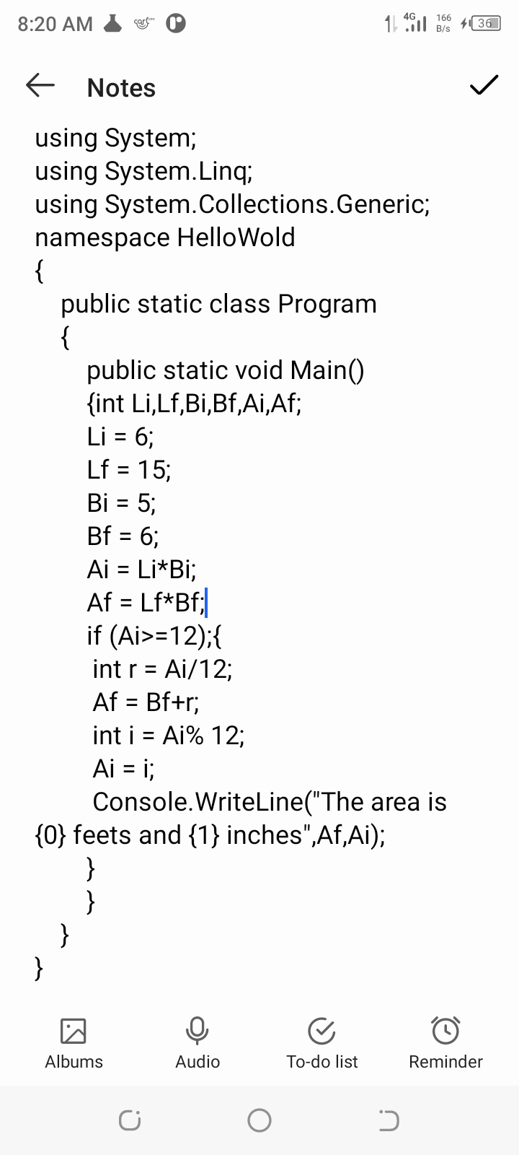

Output:
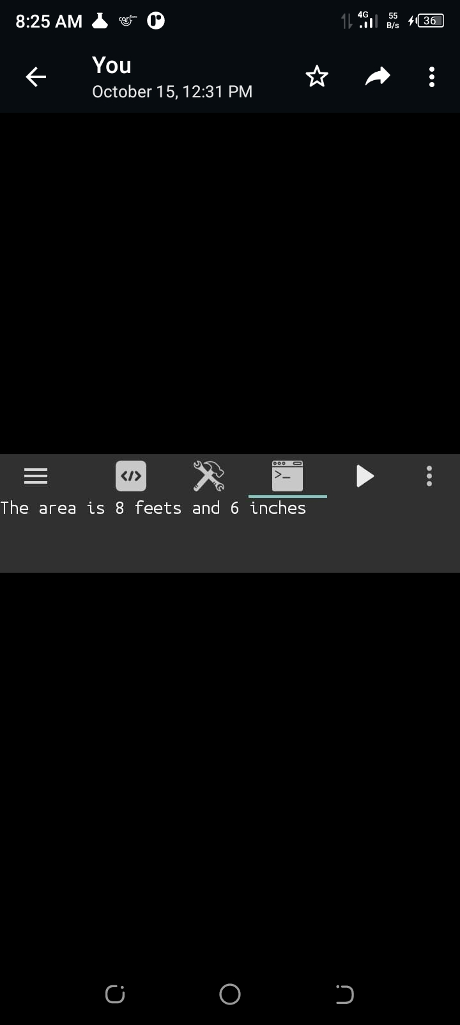

Task no.2: Calculate the temperature in farhenite.
Solution:
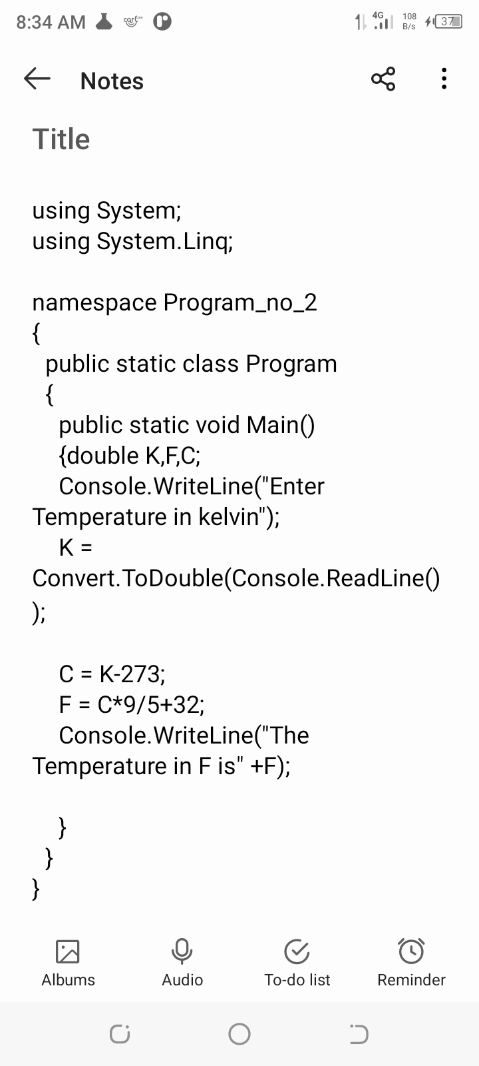

Output:

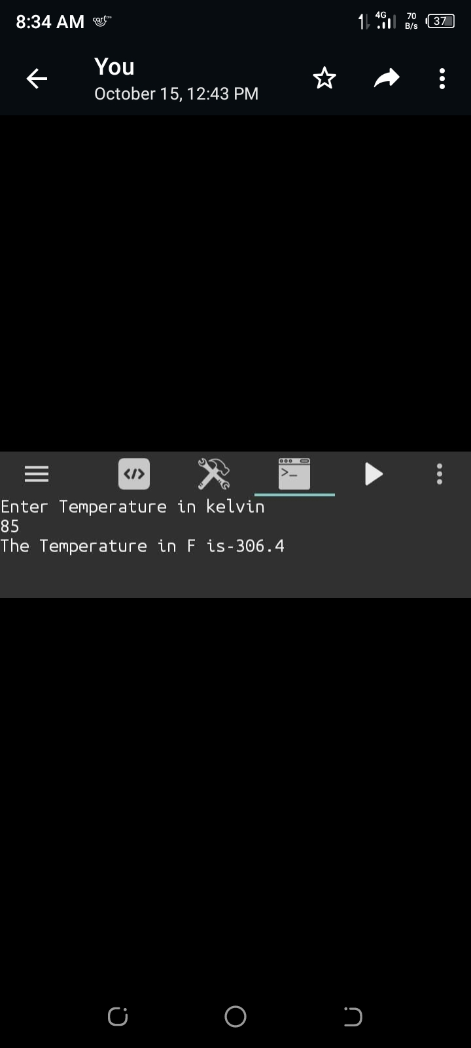

Task no.3: using c# calculate the distance.
Solution:
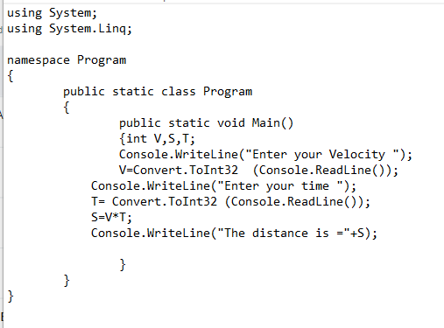

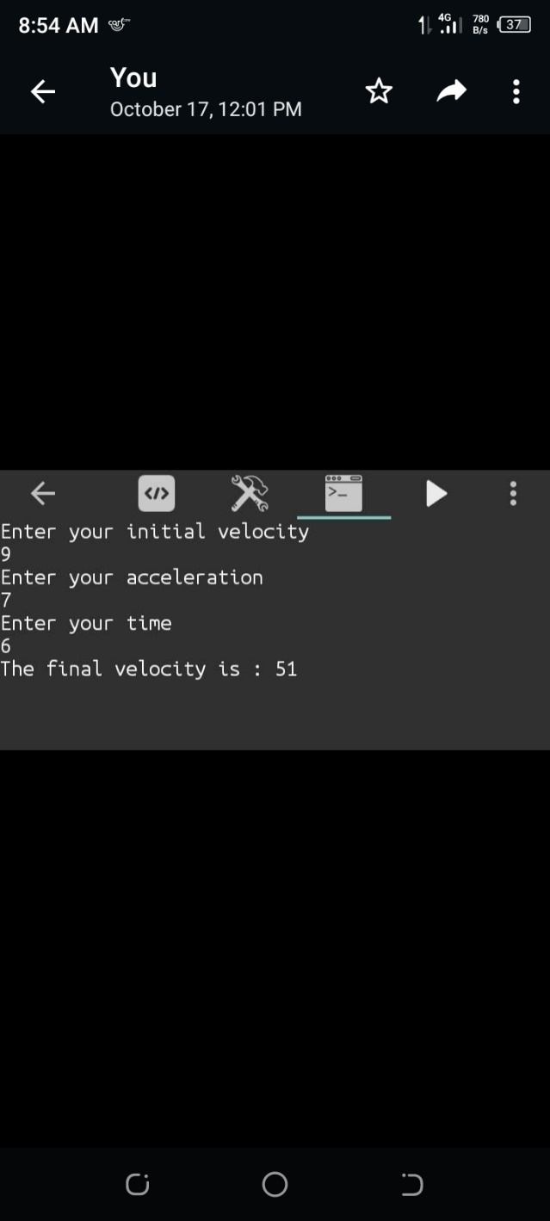
Output:

Task no.4: using c# calculate the final velocity in first equation of motion.
Solution:

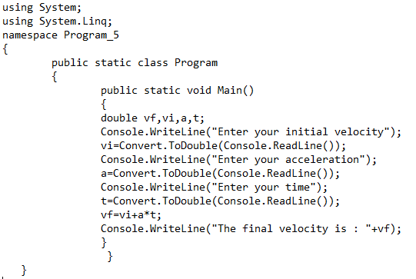

Output:

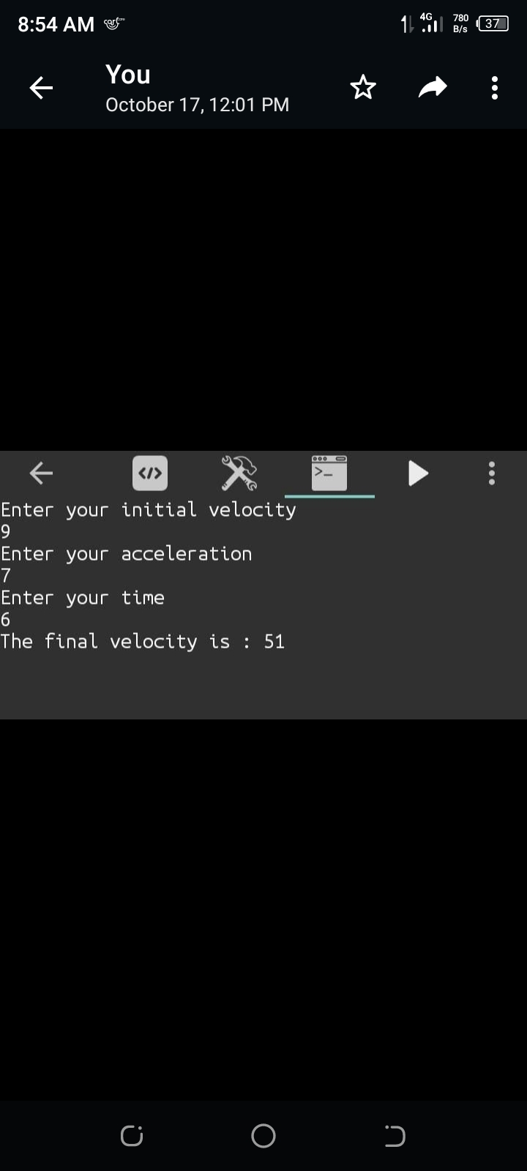

Task no.5: using c# calculate the distance in third equation of motion.
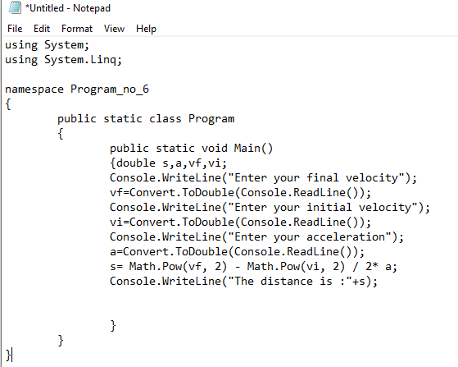
Solution:

Output:

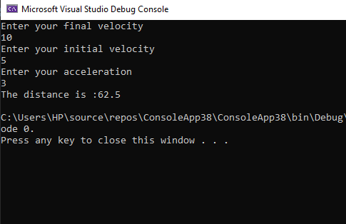

Task no.6: using c# calculate the final velocity in second equation of motion.
Solution:
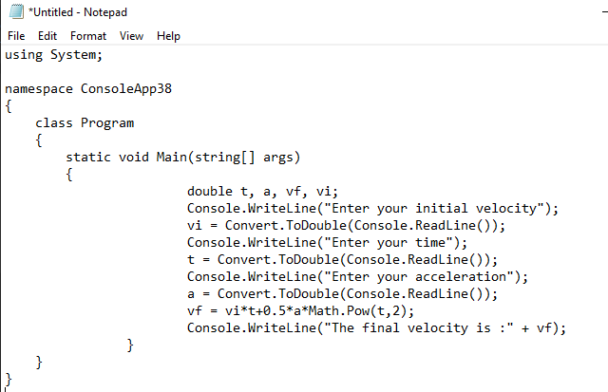
Output:
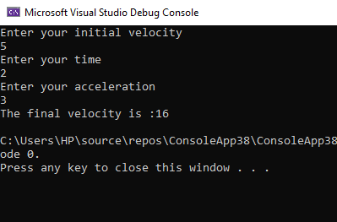

Task no.7: using c# determine the even odd no.
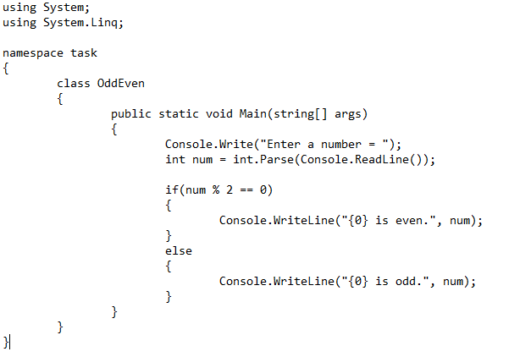
Solution:

Output:
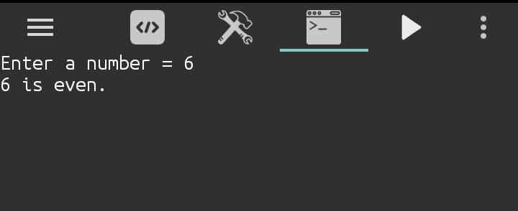

Task no.8: using c# identify the hypotenuse as the greatest side of right triangle.
Solution:
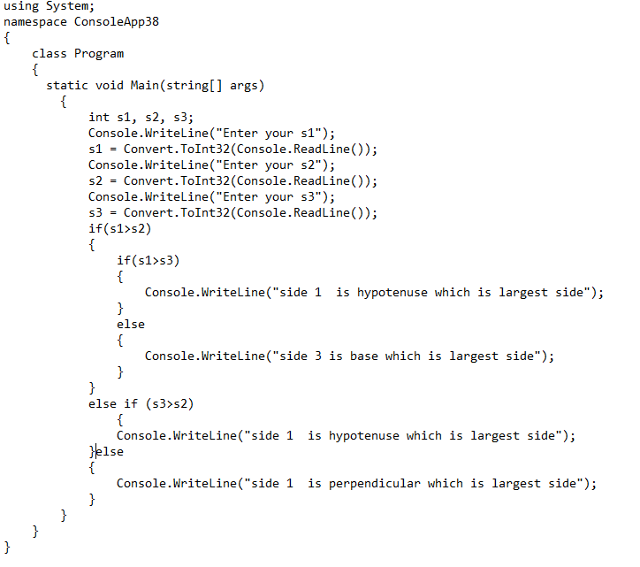
Output:

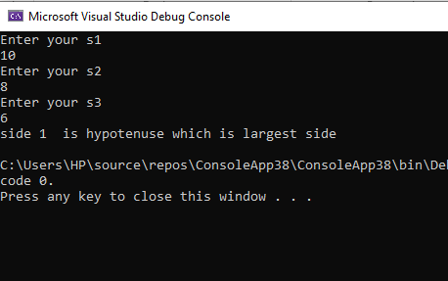

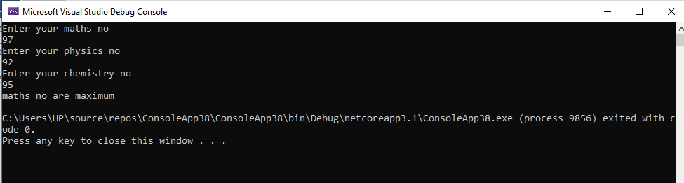
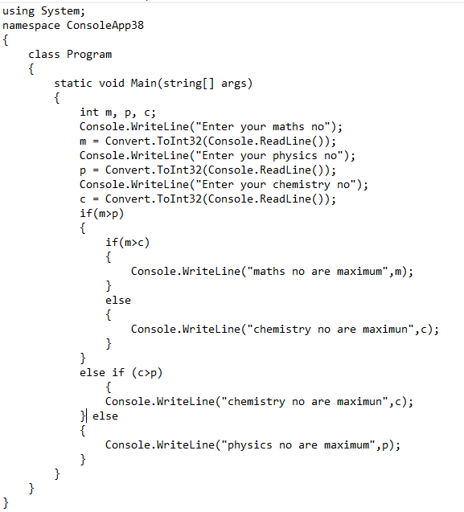
using System;

namespace ConsoleApp44
{
class Program
{
static void Main(string[] args)
{
Console.WriteLine("Is electricity is avaliable(press yes if it otherwise no)");
string electricity = Console.ReadLine();
Console.WriteLine("Is Door is open(press yes if it otherwise no)");
string dooropen = Console.ReadLine();
if (electricity == ("yes") && dooropen == ("yes"))
{
Console.WriteLine("As the door is open and also electricity is avaliale so theory and lab class will be conducted");
} else if(dooropen==("yes"))
{
Console.WriteLine("As the door is open so theory class will be conducted");
}
else if (electricity == ("yes"))
{
Console.WriteLine(" As electricity is avaliable so lab class will be conducted");
}
else
{
Console.WriteLine("As the door is close and electricity is also not avaliale so theory and lab class will not be conducted");
}
}
}

}

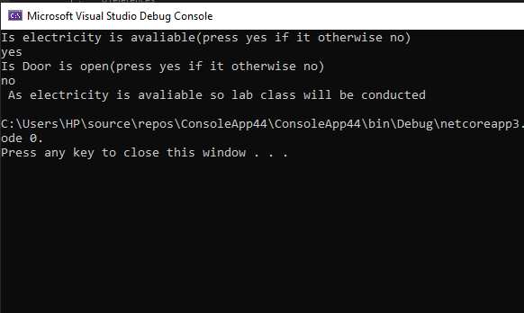

Example: 3
Solution:
using System;
using System.Linq;

namespace ConsoleApp37
{
class Program
{
static void Main(string[] args)
{
string uid, pwd;

Console.WriteLine("Enter Username: ");
uid = Console.ReadLine();
Console.WriteLine("Enter Password: ");
pwd = Console.ReadLine();

if (uid == "RMHAMMAD" || pwd == "85079600")
{
Console.WriteLine("\t Welcome! ");
}
else
{
Console.WriteLine("Invalid User id & password ");
}
}
}
}

Output:
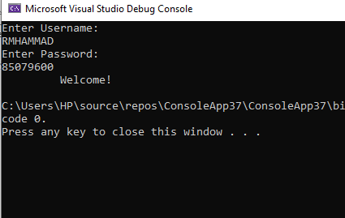

using System;

namespace ConsoleApp47
{
class Program
{
static void Main(string[] args)
{
double bamount, pmt, disc;
Console.WriteLine("Enter your billing amount");
bamount = Convert.ToDouble(Console.ReadLine());
if(bamount >100)
{
disc = bamount * 10 /100 ;
pmt = bamount - disc;
Console.WriteLine("your payement is:" + pmt);

} else
{
disc = 0;
pmt = bamount - disc;
Console.WriteLine("your payement is:" + pmt);
}
}
}
}

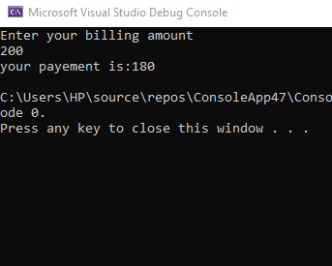

Example of Do- While:
1. Given the information such as age and to maintain a list of Student aged above 20.
SOLUTION:
using System;

namespace ConsoleApp27
{
class Program
{
static void Main(string[] args)
{
int age, n=0;
char rep='Y';
{ Console.WriteLine("enter age");
age = Convert.ToInt32(Console.ReadLine());
if(age>20)
{
n++;
}

Console.WriteLine("Is he is last student");
rep = Convert.ToChar(Console.ReadLine());
while (rep == n) ;
Console.WriteLine("THE STUDENTS AGE WHICH IS (age>20) ; {0}",n);

}
}
}
}

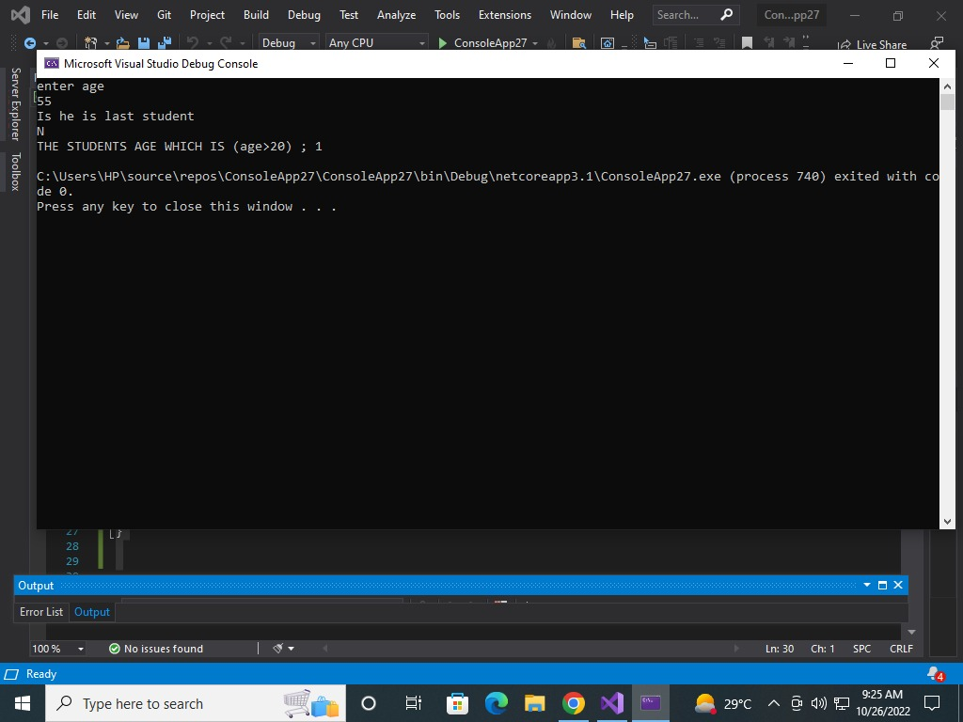
Output:

2.

SOLUTION:
using System;

namespace program
{
class doWhile
{
public static void Main(string[] args)
{
string name;
int age;
int n = 0;
string choice;
bool continueEntering = true;

do
{
Console.Write("Enter Name = ");
name = Console.ReadLine();
Console.Write("Enter Age = ");
age = Convert.ToInt32(Console.ReadLine());

if (age > 20)
{
n++;
}

Console.WriteLine("Are they the last student?");
choice = Console.ReadLine();
if (choice == "No" || choice == "no")
{
Console.Write("Enter Name = ");
name = Console.ReadLine();
Console.Write("Enter Age = ");
age = Convert.ToInt32(Console.ReadLine());
}
else if (choice == "Yes" || choice == "yes")
{
continueEntering = false;
break;
}

} while (continueEntering = true);

Console.WriteLine("Number of students over 20 are {0}", n);
Console.ReadLine();
}
}
}

Output:
